5.1 Generate the coefficients of an FIR High-Pass filter using Rectangular windowing techniques.

CODING :
clc; clear; close all;
%% --- Input Parameters ---
fp = 1000; % High-pass cutoff frequency (Hz)
fs = 8000; % Sampling frequency (Hz)
N = 50; % Filter order
wc = fp/(fs/2); % Normalized cutoff (0–1)
%% --- FIR High Pass using Hamming Window ---
b_hamm = fir1(N, wc, 'high', hamming(N+1));
disp('--- High-Pass Coefficients (Hamming Window) ---'); disp(b_hamm');
%% --- Frequency Response Plots ---
figure;
freqz(b_hamm,1);
title('High-pass FIR using Hamming Window'); title('High-pass FIR using Hanning Window');

OUTPUT 1:

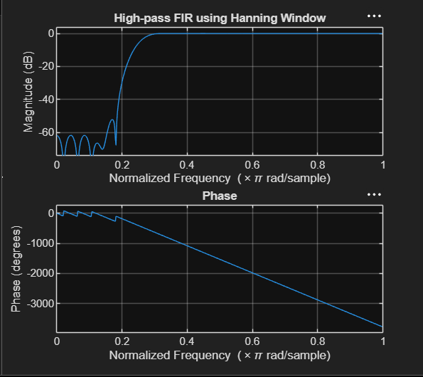

RESULT :
--- High-Pass Coefficients (Hamming Window) ---
-0.0007
0
0.0009
0.0016
0.0015
0
-0.0024
-0.0044
-0.0039
0
0.0060
0.0103
0.0088
0
-0.0128
-0.0217
-0.0184
0
0.0268
0.0464
0.0410
0
-0.0725
-0.1567
-0.2240
0.7493
-0.2240
-0.1567
-0.0725
0
0.0410
0.0464
0.0268
0
-0.0184
-0.0217
-0.0128
0
0.0088
0.0103
0.0060
0
-0.0039
-0.0044
-0.0024
0
0.0015
0.0016
0.0009
0
-0.0007

>>

